

User Manual

reading terminal

Checkpoint attendance system

2017

Table Of Contents

1 Introduction 3

1.1 About The User Manual 3

1.2 Quick Install Guide 3

2 Getting Started With The Reading Terminal 4

2.1 Setting Up Your Reading Terminal 4

2.2 Logging In 4

3 Host Control Panel 5

3.1 Starting An Appointment 5

3.2 Logging Out 5

4 Active Appointment Panel 6

4.1 Registration Results 6

4.1.1 Successful 6

4.1.2 Already Registered 7

4.1.3 Failed 7

4.1.4 No Database Connection 8

4.2 Ending/Pausing An Appointment 9

5 Troubleshooting 10

6 Contact Us 11

# Introduction

## About The User Manual

The user manual covers all features and functionality found in the CheckPoint Reading Terminal.

## Quick Install Guide

No installation is needed for the reading terminal. It comes pre-configured with the necessary software.

# Getting Started With The Reading Terminal

As a CheckPoint host, you have received this reading terminal for registering attendance at your course/appointment. The RFID reading unit is pre-configured and need only be connected to the accompanied terminal via the USB-connector found on the reading unit.

## Setting Up Your Reading Terminal

Upon receiving your reading terminal, make sure it consist of two parts:

1. A terminal unit with a display
2. A RFID reading unit

## Logging In

Once you turn on the reading terminal and the software starts up, you will be greeted by the log in screen shown in *Figure 2‑1: Login screen*. In order to log in to the CheckPoint reading terminal, you are required to have a valid host account. If you have forgotten your login information, please contact the CheckPoint staff on your host homepage.

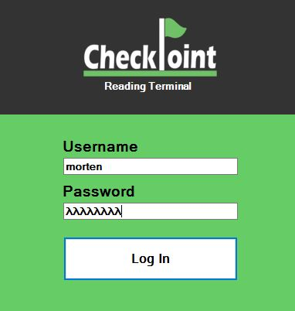

Figure ‑1: Login screen

On the login screen, enter your host account information and click the “Log In” button. This will log you in and redirect you to the host control panel.

# Host Control Panel

After successfully logging in, you are redirected to the Host Control Panel, shown in *Figure 3‑1: Host control panel*. Here you will find all the appointments you are hosting, sorted by date. Once an appointment’s date has passed, it will no longer show in the appointment list.

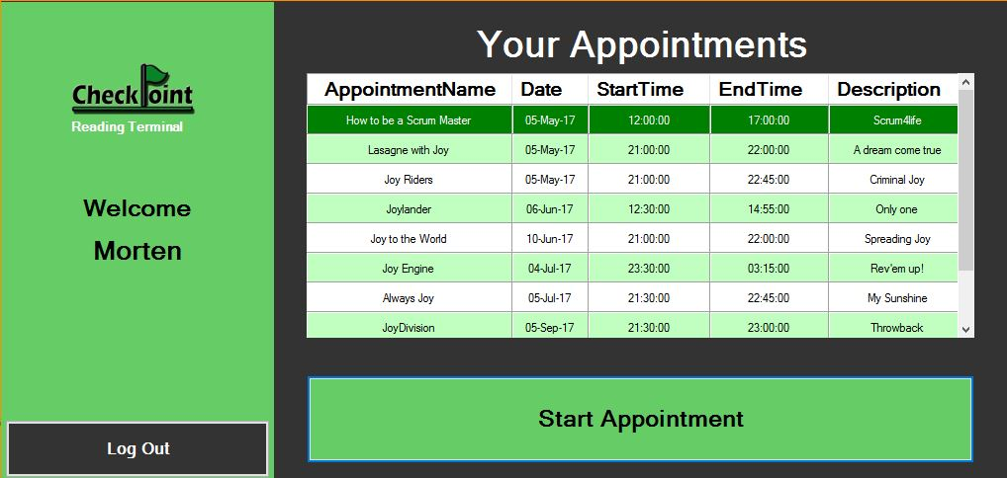

Figure ‑1: Host control panel

## Starting An Appointment

In order to initiate an appointment you are hosting, simply click on the desired appointment in the appointment list. The selected appointment will be highlighted in dark green.

Make sure the RFID reading unit is correctly connected to the terminal, or you will not be allowed to start the appointment.

When you have highlighted the appointment you wish to start, click the “Start Appointment” button. This will redirect you to the Active Appointment Panel.

## Logging Out

In order to log out, simply click the “Log Out” button found in the bottom left corner of the Host Control Panel. This will redirect you back to the Login Screen.

# Active Appointment Panel

When an appointment has been selected and started, you will be redirected to the Active Appointment Panel, as shown in *Figure 4‑1: Active appointment panel*. This panel is what your attendees will see when they show up to register their attendance and will display the name of the active appointment.

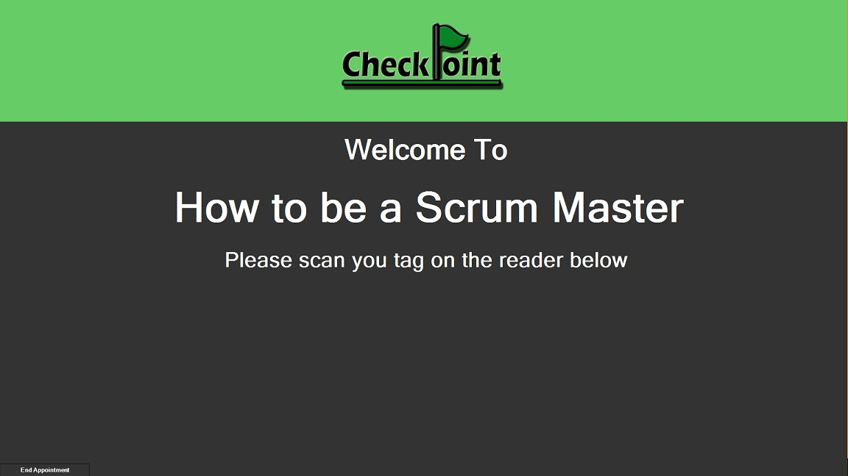

Figure ‑1: Active appointment panel

This screen will lock as the top-most screen in order to prevent any other windows or panels from being opened during an active appointment. To get around this, see *4.2 Ending/Pausing An* Appointment.

## Registration Results

When an attendee swipes his unique identifier tag, he will receive instant feedback in the form a registration result displayed on the Active Appointment Panel. Each of these registration results are explained below.

### Successful

A “successful” registration result, as shown in *Figure 4‑2: "Successful" status*, means the attendee is registered for the appointment and that the registration was successful. He will be updated with the date and time of the registration, as well as having his status changed to “Attended”.

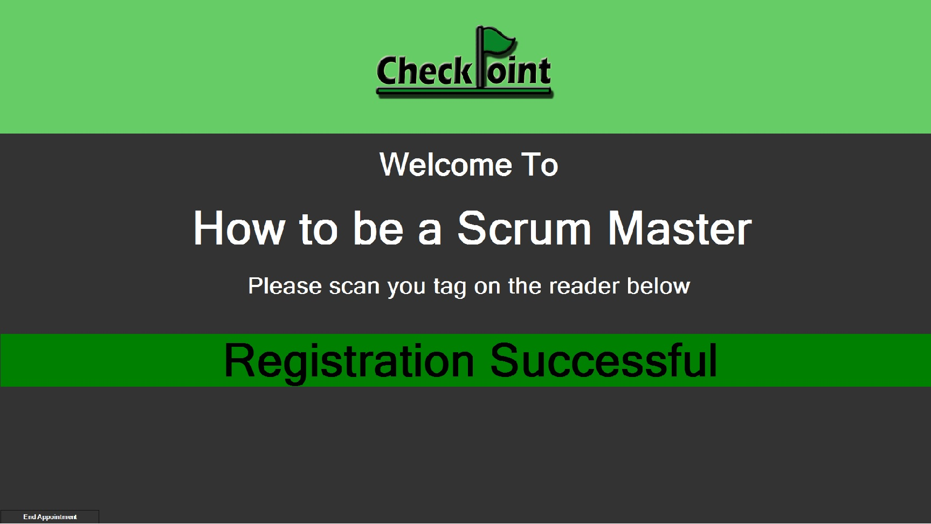

Figure ‑2: "Successful" status

### Already Registered

An “Already Registered” registration status, as shown in *Figure 4‑3: "Already registered" status*, means the attendee has already swiped his unique identifier tag for the active appointment and is already registered with a date and time.

The attendee’s originally registered date and time will not be overwritten.

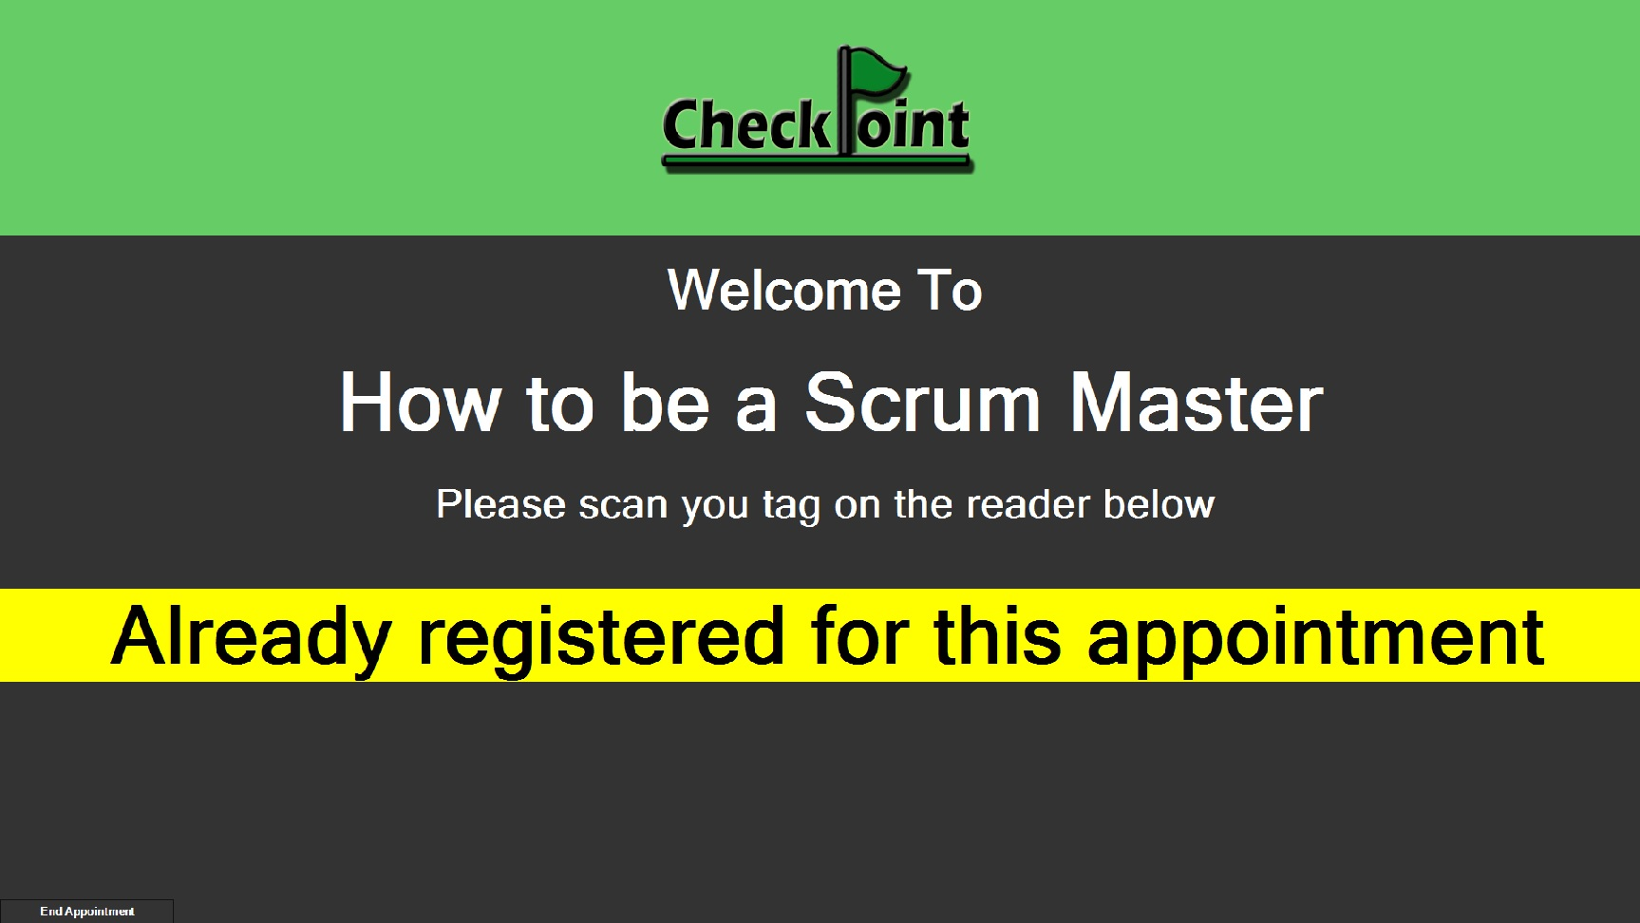

Figure ‑3: "Already registered" status

### Failed

A “Failed” registration status, as shown in *Figure 4‑4: "Failed" status*, means the registration was not successful and the attendance was not registered. This usually indicated that the attendee has not been accepted to attend the appointment, and is therefore not able to register.

A “Failed” status can also indicate a fault on the attendee’s unique identifier tag.

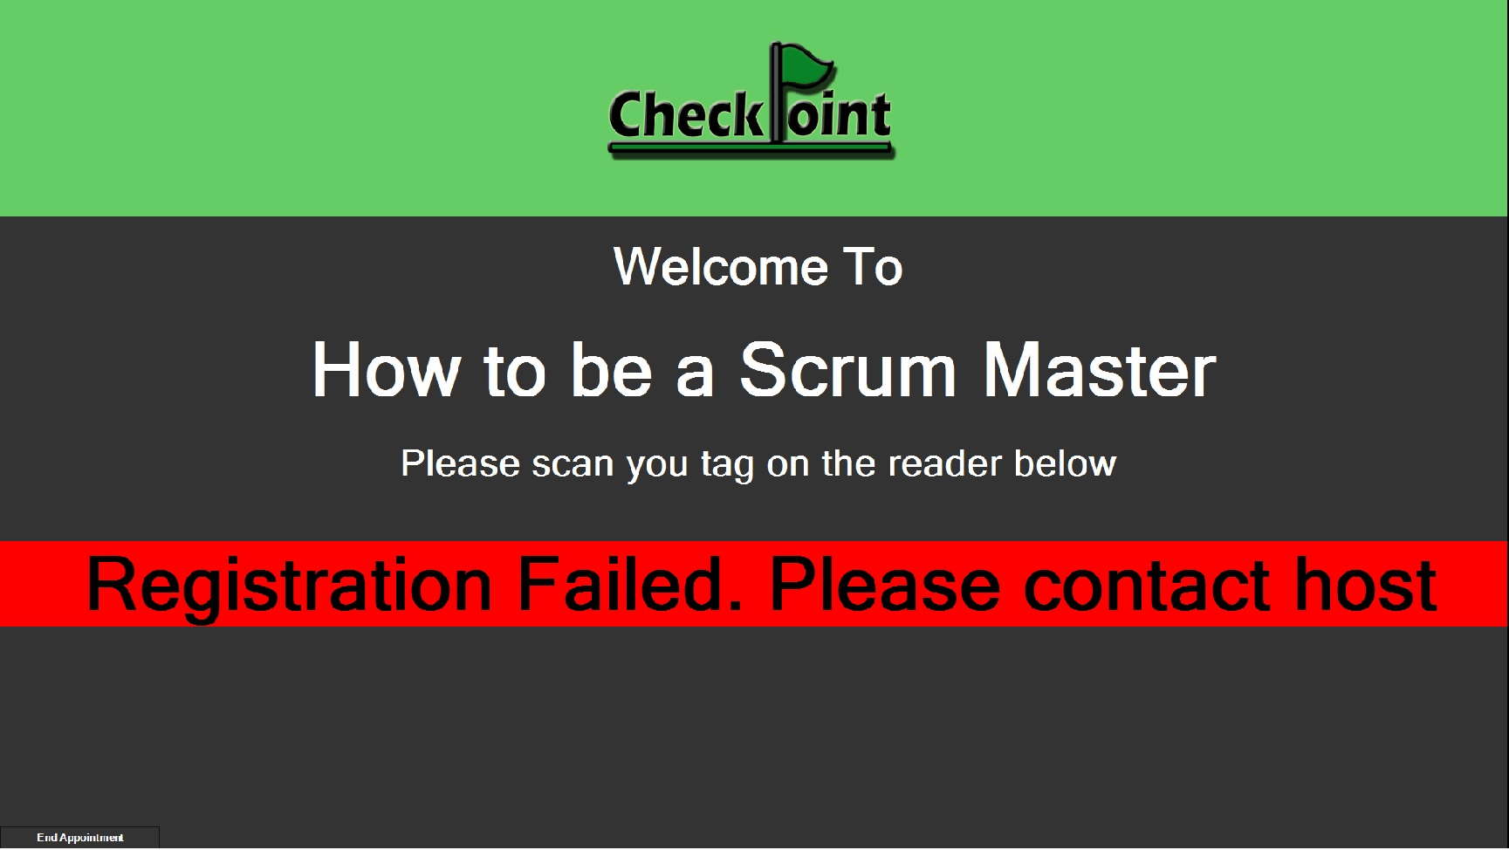

Figure 4‑4: "Failed" status

### No Database Connection

A “No Database Connection” registration status, as shown in *Figure 4‑5: "No database connection" status*, means the reading terminal is unable to connect to the server and therefore also unable to register attendance. This usually happens when the reading terminal does not have an active internet connection.

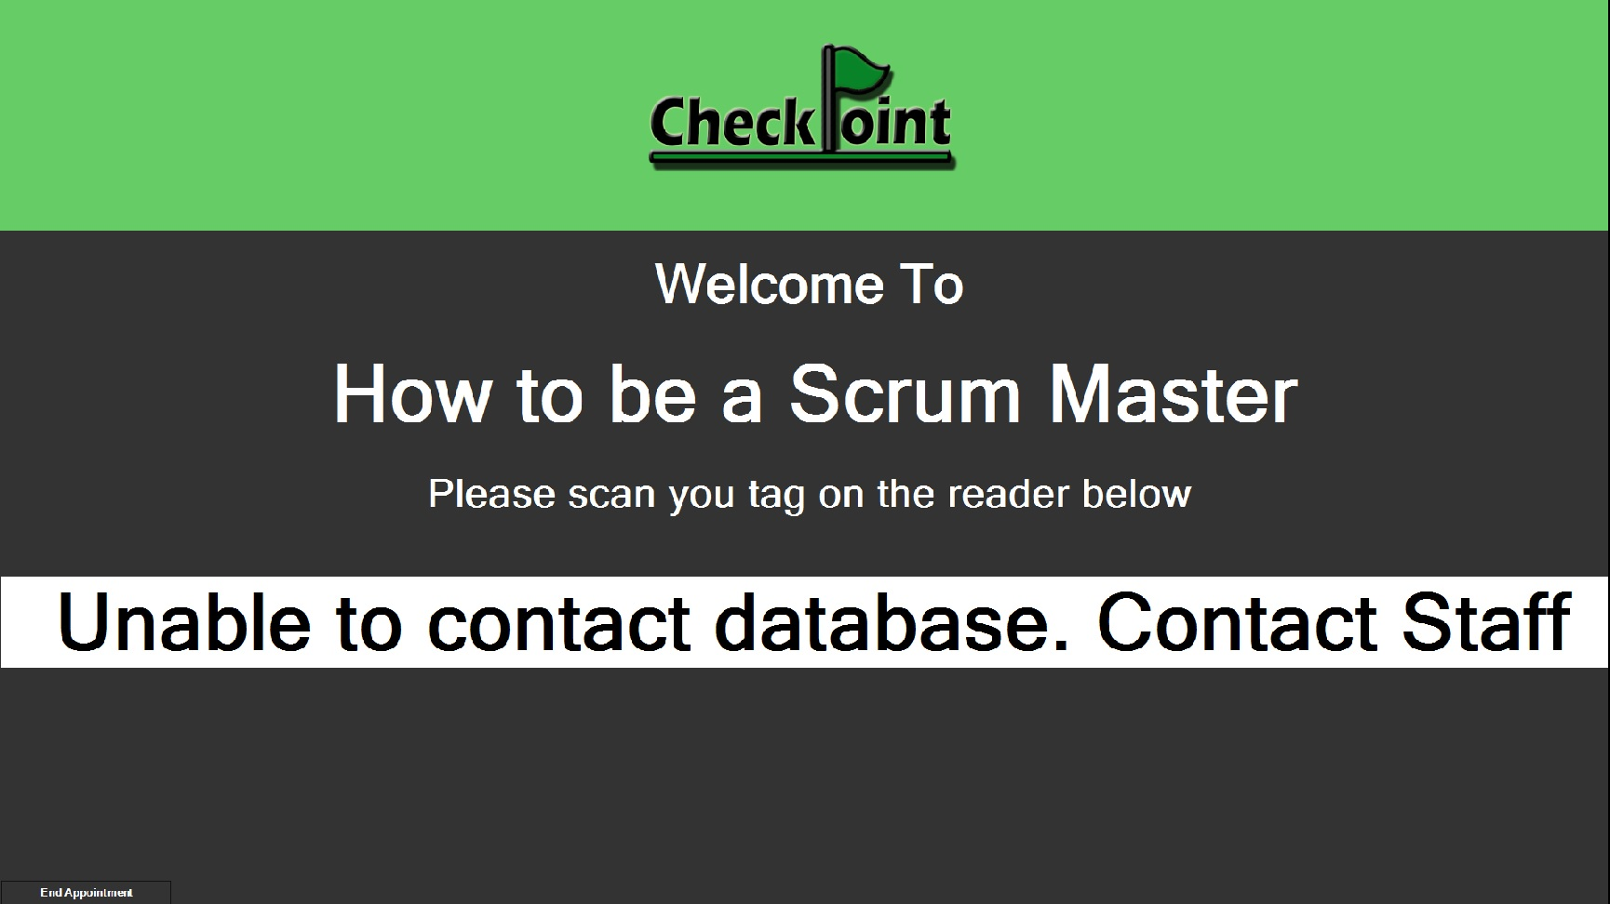

Figure 4‑5: "No database connection" status

## Ending/Pausing An Appointment

If your appointment has ended, or you wish to pause the active appointment for any reason, you may do so by clicking the “End Appointment” button on the bottom-left corner of the Active Appointment Panel, as shown in *Figure 4‑6: End/pause active appointment*.

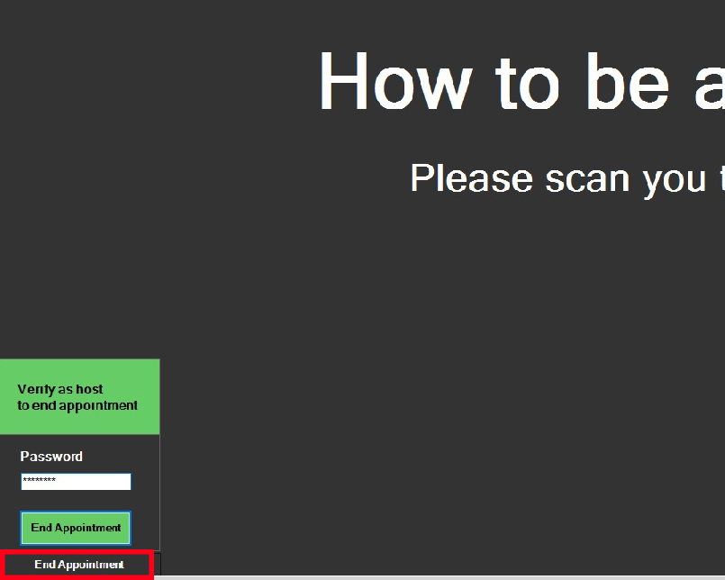

Figure 4‑6: End/pause active appointment

When requesting to end the appointment, you will be asked to verify your host status by re-entering your password. Upon successful verification of your host details, you will be redirected back to the Host Control Panel.

Once back on the Host Control Panel, you may choose to resume the recently ended appointment by starting it again, as explained in *3.1 Starting An Appointment*.

# Troubleshooting

This chapter will address the most common problems you might experience when using the CheckPoint Attendance software. It will be presented in a Q&A style.

*Add this if needed*

# Contact Us